COS30043 Project Report
Mark Saleh 103994313

Overview
My project is a web forum made in phpBB, with added VueJS components. The forum leverages a responsive design, combining AJAX requests with Vue to update data without refreshing the page, and is user-friendly across various devices.

Features

Row-column grid system
The default phpBB forum uses a row-column grid system to create an organised and visually appealing UI. Below are some examples of this:
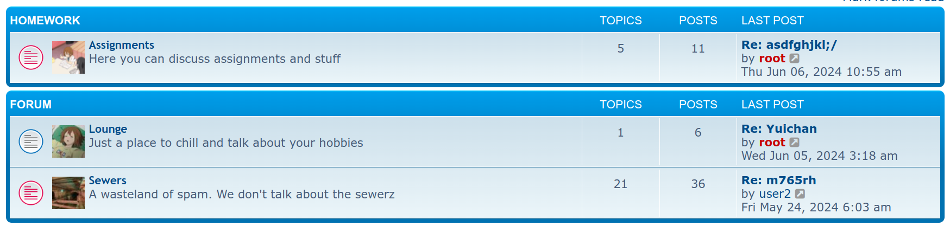
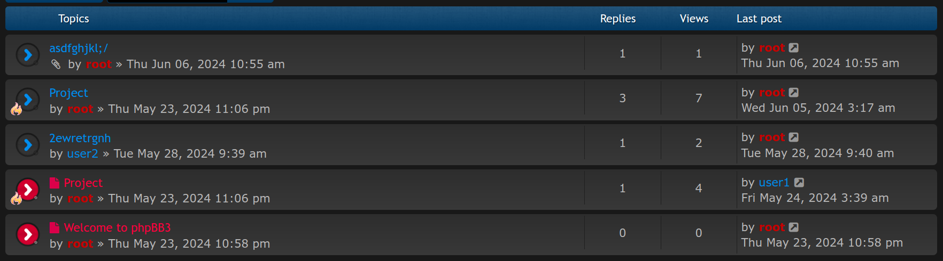
Figures 0 and 1
And here is how it is implemented in the code:
<ul class="topiclist">
<li class="header">
<dl class="row-item">
<dt><div class="list-inner">Topics</div></dt>
<dd class="posts">Replies</dd>
<dd class="views">Views</dd>
<dd class="lastpost"><span>Last post</span></dd>
</dl>
</li>
</ul>
<ul class="topiclist topics">

<li class="row bg1">
<dl class="row-item topic_read_mine">
<div class="list-inner">
<a href="./viewtopic.php?t=27" class="topictitle">asdfghjkl;/</a>
</div>
<dd class="posts">1 <dfn>Replies</dfn></dd>
<dd class="views">1 <dfn>Views</dfn></dd>
<dd class="lastpost">
<span><dfn>Last post </dfn>
</span>
</dd>
</dl>
</li>

<li class="row bg2">
<dl class="row-item topic_read_mine">
<div class="list-inner">
<a href="./viewtopic.php?t=3" class="topictitle">Project</a>
</div>
<dd class="posts">3 <dfn>Replies</dfn></dd>
<dd class="views">7 <dfn>Views</dfn></dd>
<dd class="lastpost">
<span><dfn>Last post </dfn>
</dd>
</dl>
</li>

Components, routers and custom directives
VueJS routers and components were integrated into the template. Below is an example of the router:
<div id="app">
<router-view></router-view>
</div>
<script>
const ForumList = {
template: '<div>Forum List</div>'
};
const TopicList = {
template: '<div>Topic List</div>'
};
const routes = [
{ path: '/', component: ForumList },
{ path: '/topics', component: TopicList }
];

Arrays for dynamic data handling
Arrays are, by default, used for many purposes by phpBB. One example of this is for searching posts, which uses multiple arrays. Below is an example of one:
if ($sql_where)
{
$zebra = [];

if ($show_results == 'posts')
{
$sql = 'SELECT zebra_id, friend, foe
FROM ' . ZEBRA_TABLE . '
WHERE user_id = ' . $user->data['user_id'];
$result = $db->sql_query($sql);

while ($row = $db->sql_fetchrow($result))
{
$zebra[($row['friend']) ? 'friend' : 'foe'][] = $row['zebra_id'];
}
$db->sql_freeresult($result);

Core VueJS directives
The added VueJS components use core VueJS directives. Below is an example of v-for in the forumlist component:
<div>
<ul>
<li v-for="forum in forums" :key="forum.id">{{ forum.name }}</li>
</ul>
</div>

Forms with data validation
PhpBB’s default login form uses data validation. Below is an example of this:
$login_username = $request->variable('login_username', '', true, \phpbb\request\request_interface::POST);
$login_password = $request->untrimmed_variable('login_password', '', true, \phpbb\request\request_interface::POST);
$login_result = $auth_provider->login($login_username, $login_password);

Mobile-first approach
PhpBB is, by default, mobile friendly. Below is an example of this:
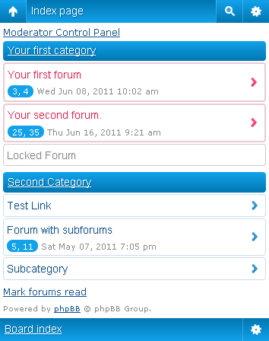
Figure 3

Pagination

Figure 4
Pagination is included by default in phpBB. Here is how it is implemented in the code:
<div class="pagination">
21 topics
<ul>
<li class="arrow previous"><a class="button button-icon-only" href="./viewforum.php?f=4" rel="prev" role="button"><i class="icon fa-chevron-left fa-fw" aria-hidden="true"></i><span class="sr-only">Previous</span></a></li>
<li><a class="button" href="./viewforum.php?f=4" role="button">1</a></li>
<li class="active"><span>2</span></li>
<li><a class="button" href="./viewforum.php?f=4&amp;start=20" role="button">3</a></li>
<li class="arrow next"><a class="button button-icon-only" href="./viewforum.php?f=4&amp;start=20" rel="next" role="button"><i class="icon fa-chevron-right fa-fw" aria-hidden="true"></i><span class="sr-only">Next</span></a></li>
</ul>
</div>

